Foil Coach  Anastasiia Sadii  604-8024637 / nastiyasadiy22@gmail.com  Private lesson: M-F 4-8:30pm; Sat 12-5pm  $40/20 min  Group Class: M/W/F 6:40-7:40; Sat 4-5  $20/class $250/month  Nicole yuan  647-6185832 / Fencing88foil@gmail.com  Private lesson: M/W/F 5-9 pm; $40/20 min  Evgeny Bozhenko  bozhenko@hotmail.com  Private lesson: M/W/F 5-9pm; $40/30min  Ysa granert  647-8303913 / ysabel.granert@gmail.com  Private Lesson: M/W/F 4-8 $20/20 min  Beginner Class: F 5-6 pm Foil Kid  $15 member; $25 non member | 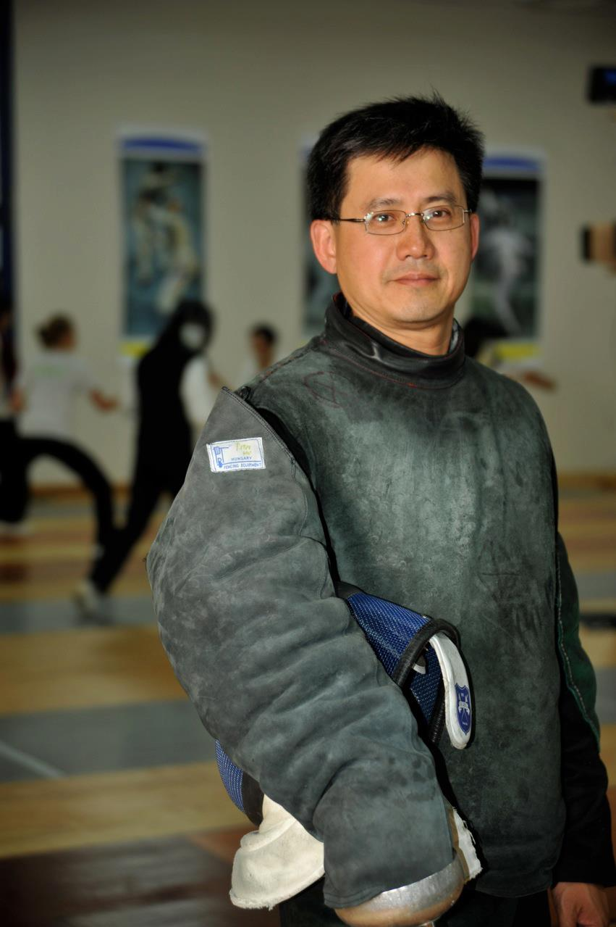  Peter Ho  fencers are welcome to train seven days a week  Foil M/T/W/T/F/S  Epee M/T/W/T/S/S  Mon - Fri 4-10 pm  Sat 10-6 pm; Sun 10-2 pm | Toronto Fencing Club  Coaches  Established 1998
3 Weapons Coach  foil/epee/sabre  peter ho  647-2725438 / tfcpeterho@rogers.com  Private lesson: M-F 4:20-9:20pm; Sat 10-6pm  $20/member; $40/non-member for 20 min  Simon duran  647-5250719 / simonduran81/hotmail.com  Private lesson: Sat AM $35/30min  2 weapons coach  foil/epee  Chris granert  416-4008169 / cwgranert@gmail.com  Private lesson: M-F 4-9 pm, Sat 11-6 $30/20min  Adult Epee Class: Sun 10-12 $20/class ($40 non-member) | Epee Coach  Hunter Yu  437-9809899 / hunteryu2006@gmail.com  Private lesson M-F 6-9 pm, Sat 1-5 pm $20/20min  Evelyn Zheng  647-5379991  evelynzhengfencing@gmail.com  Private Lesson: M 5-7, T 5-6:20, Th 5-6:20  $30 /20 min member ($40 non member)  Cathy granert  647-4493913 / acgranert@gmail.com  Private Lesson: Sat 12-2 $20/20 min  Adult Beginner Class: F 7:45-8:45 pm  William wong  647-2273838 / wwong@vanderson.com  Private lesson: Sat & Sun 10-2 $50/30 min | Epee coach  Tim svidnytskiy  647-9725589 /fencingcoachtim@gmail.com  Private lesson: M-Th 4-9pm; Sat 10-5pm  $240/8 x 20 min; $40/20 min non-member  Nicholas Hepner  416-2207552 / nhepner42@gmail.com  Private Lesson: T/T 7:30-9:30, Sun 10:30-12:30 pm; $40/20 min  Viktor Melnyk  437-3135155 / vitia20051112@gmail.com  Private lesson: M-F 4-8:30pm; Sat 12-5pm  $40/20 min  Group Class: T/W/T 6-7; Sat 12-1  $20/class; $250/month
647-2725438 | 50 Prince Andrew place, toronto, M3C 2H4 | www.torontofencing.com  info@torontofencing.com

