Foil Coach  Stella Kim  647-3357570 /j5s8w8s1@gmail.com  Private lesson: M-F 4-9pm; S&S 9-4 $40/20min  Steven Zhang  416-9022833  steven.sh.zhang@hotmail.com  Private lesson: M W F 6-8 pm; Sat 12-4 $30/20min  Mohammand mirmohammadi  647-4648177/ moesfencing@gmail.com  Private lesson: M-F 4-9:00pm; Sat 9am- 6pm  Sun 12:30- 3 pm $60/20 min  Group Class: M/F 6:00-7:30  $40/class | 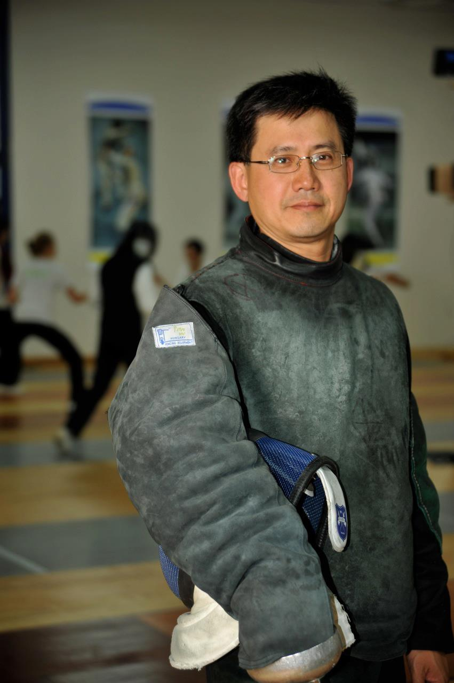  Peter Ho  fencers are welcome to train seven days a week  Foil M/T/W/T/F/S  Epee M/T/W/T/S/S  Mon - Fri 4-10 pm  Sat 10-6 pm; Sun 10-2 pm | Toronto Fencing Club  Coaches  Established 1998  
3 Weapons Coach  foil/epee/sabre  peter ho  647-2725438 / tfcpeterho@rogers.com  Private lesson: M-F 4:40-9:00pm; Sat 12-6pm  $30/member; $60/non-member for 20 min  Simon duran  647-5250719 / simonduran81/hotmail.com  Private lesson: Sat AM $35/30min  2 weapons coach  foil/epee  Chris granert  416-4008169 / cwgranert@gmail.com  Private lesson: M-F 4-9 pm, Sat 11-6 $30/20min  Adult Epee Class: Sun 10-12 $20/class ($40 non-member)  Rick Wu  647-9850415 / rick473@gmail.com  Private lesson: Tue Wed Thu $30/20min  Kevin wang  647-8955928  kevinwangfencing@gmail.com  Private Lesson: MWF 6-9, Tue before 6;  Thu before 5 Sat 12-5  $30/20 min | Epee Coach  Andrew Hu  416-8879961 / andrewfencing@gmail.com  Private lesson M-F 3-10 pm, Sat Sun 9-5 pm $60/20min member ($80 non-member)  Youth Elite Epee Class: Wed 5-6:30 pm  Epee High Performance: Thu 5:30-7 pm $40/class ($60 non-member)  Taeyang Song  437-5750616  a83471406@gmail.com  Private Lesson: M-F 4-9, S&S 10-4  $50/20 min  Evelyn Zheng  647-5379998  evelynzhengfencing@gmail.com  Private Lesson: M 6-7, Tu 5-6:20, Th 4-5:20  $30 /20 min member ($40 non member)  Cathy granert  647-4493913 / acgranert@gmail.com  Private Lesson: Sat 12-2 $20/20 min  Adult Beginner Class: F 7:45-8:45 pm  William wong  647-2273838 / wwong@vanderson.com  Private lesson: Sat & Sun 9-2  $40/30 min, $25 for member, $40 for trial | Epee coach  Tim svidnytskiy  647-9725589 /fencingcoachtim@gmail.com  Private lesson: M-Th 4-9pm; Sat 10-5pm  $240/8 x 20 min; $40/20 min non-member  Victor ji  647-8665335 / victorji.fencing@gmail.com  Private Lesson: Tue Thu 6-9pm  $30/20 min  Viktor Melnyk  437-3135155 / vitia20051112@gmail.com  Private lesson: M-F 4-8:30pm; Sat 12-5pm  $40/20 min  Group Class: T/W/T 6-7; Sat 12-1  $20/class; $250/month  Jason li  416-7296287 / mankit0225@gmail.com  Private Lesson: M 5-9 Wed 5-9 Sat 10-5  $20/20 min member ($35 non-member)  Yandi Ramos  416-8547289  yandiramos@gmail.com  Private Lesson: M-F 4-9, S&S 10-4  $50/20 min
647-2725438 | 50 Prince Andrew place, toronto, M3C 2H4 | www.torontofencing.com  info@torontofencing.com

