Saturday  FOIL (6-9 YR): 10:30 – 12:00 Am  Mohammad mirmohammadi  647-46148177/ moesfencing@gmail.com  ($40/class)  Teen EPEE: 1:00 – 2:00 pm  Viktor Melnyk  437-3135155 /vitia20051112@gmail.com  $250/month ($25/class non-member)  EPEE & FOIL  5:00- 6:30PM  Peter HO  647-2725438 / tfcpeterho@rogers.com  $20 Peter’s student & their guest  Sunday  ADULT EPEE: 10:00-12:00  chris gRANERT  647-4493913/ acgranert@gmail.com  $20 member ($40 non-member)  HPP EPEE: 2:00-4:30  Andrew Hu  416-8879961 / andrewfencing@gmail.com  CFF HPP / USFA C classification  $40 member ($60 non-member) |  |  | 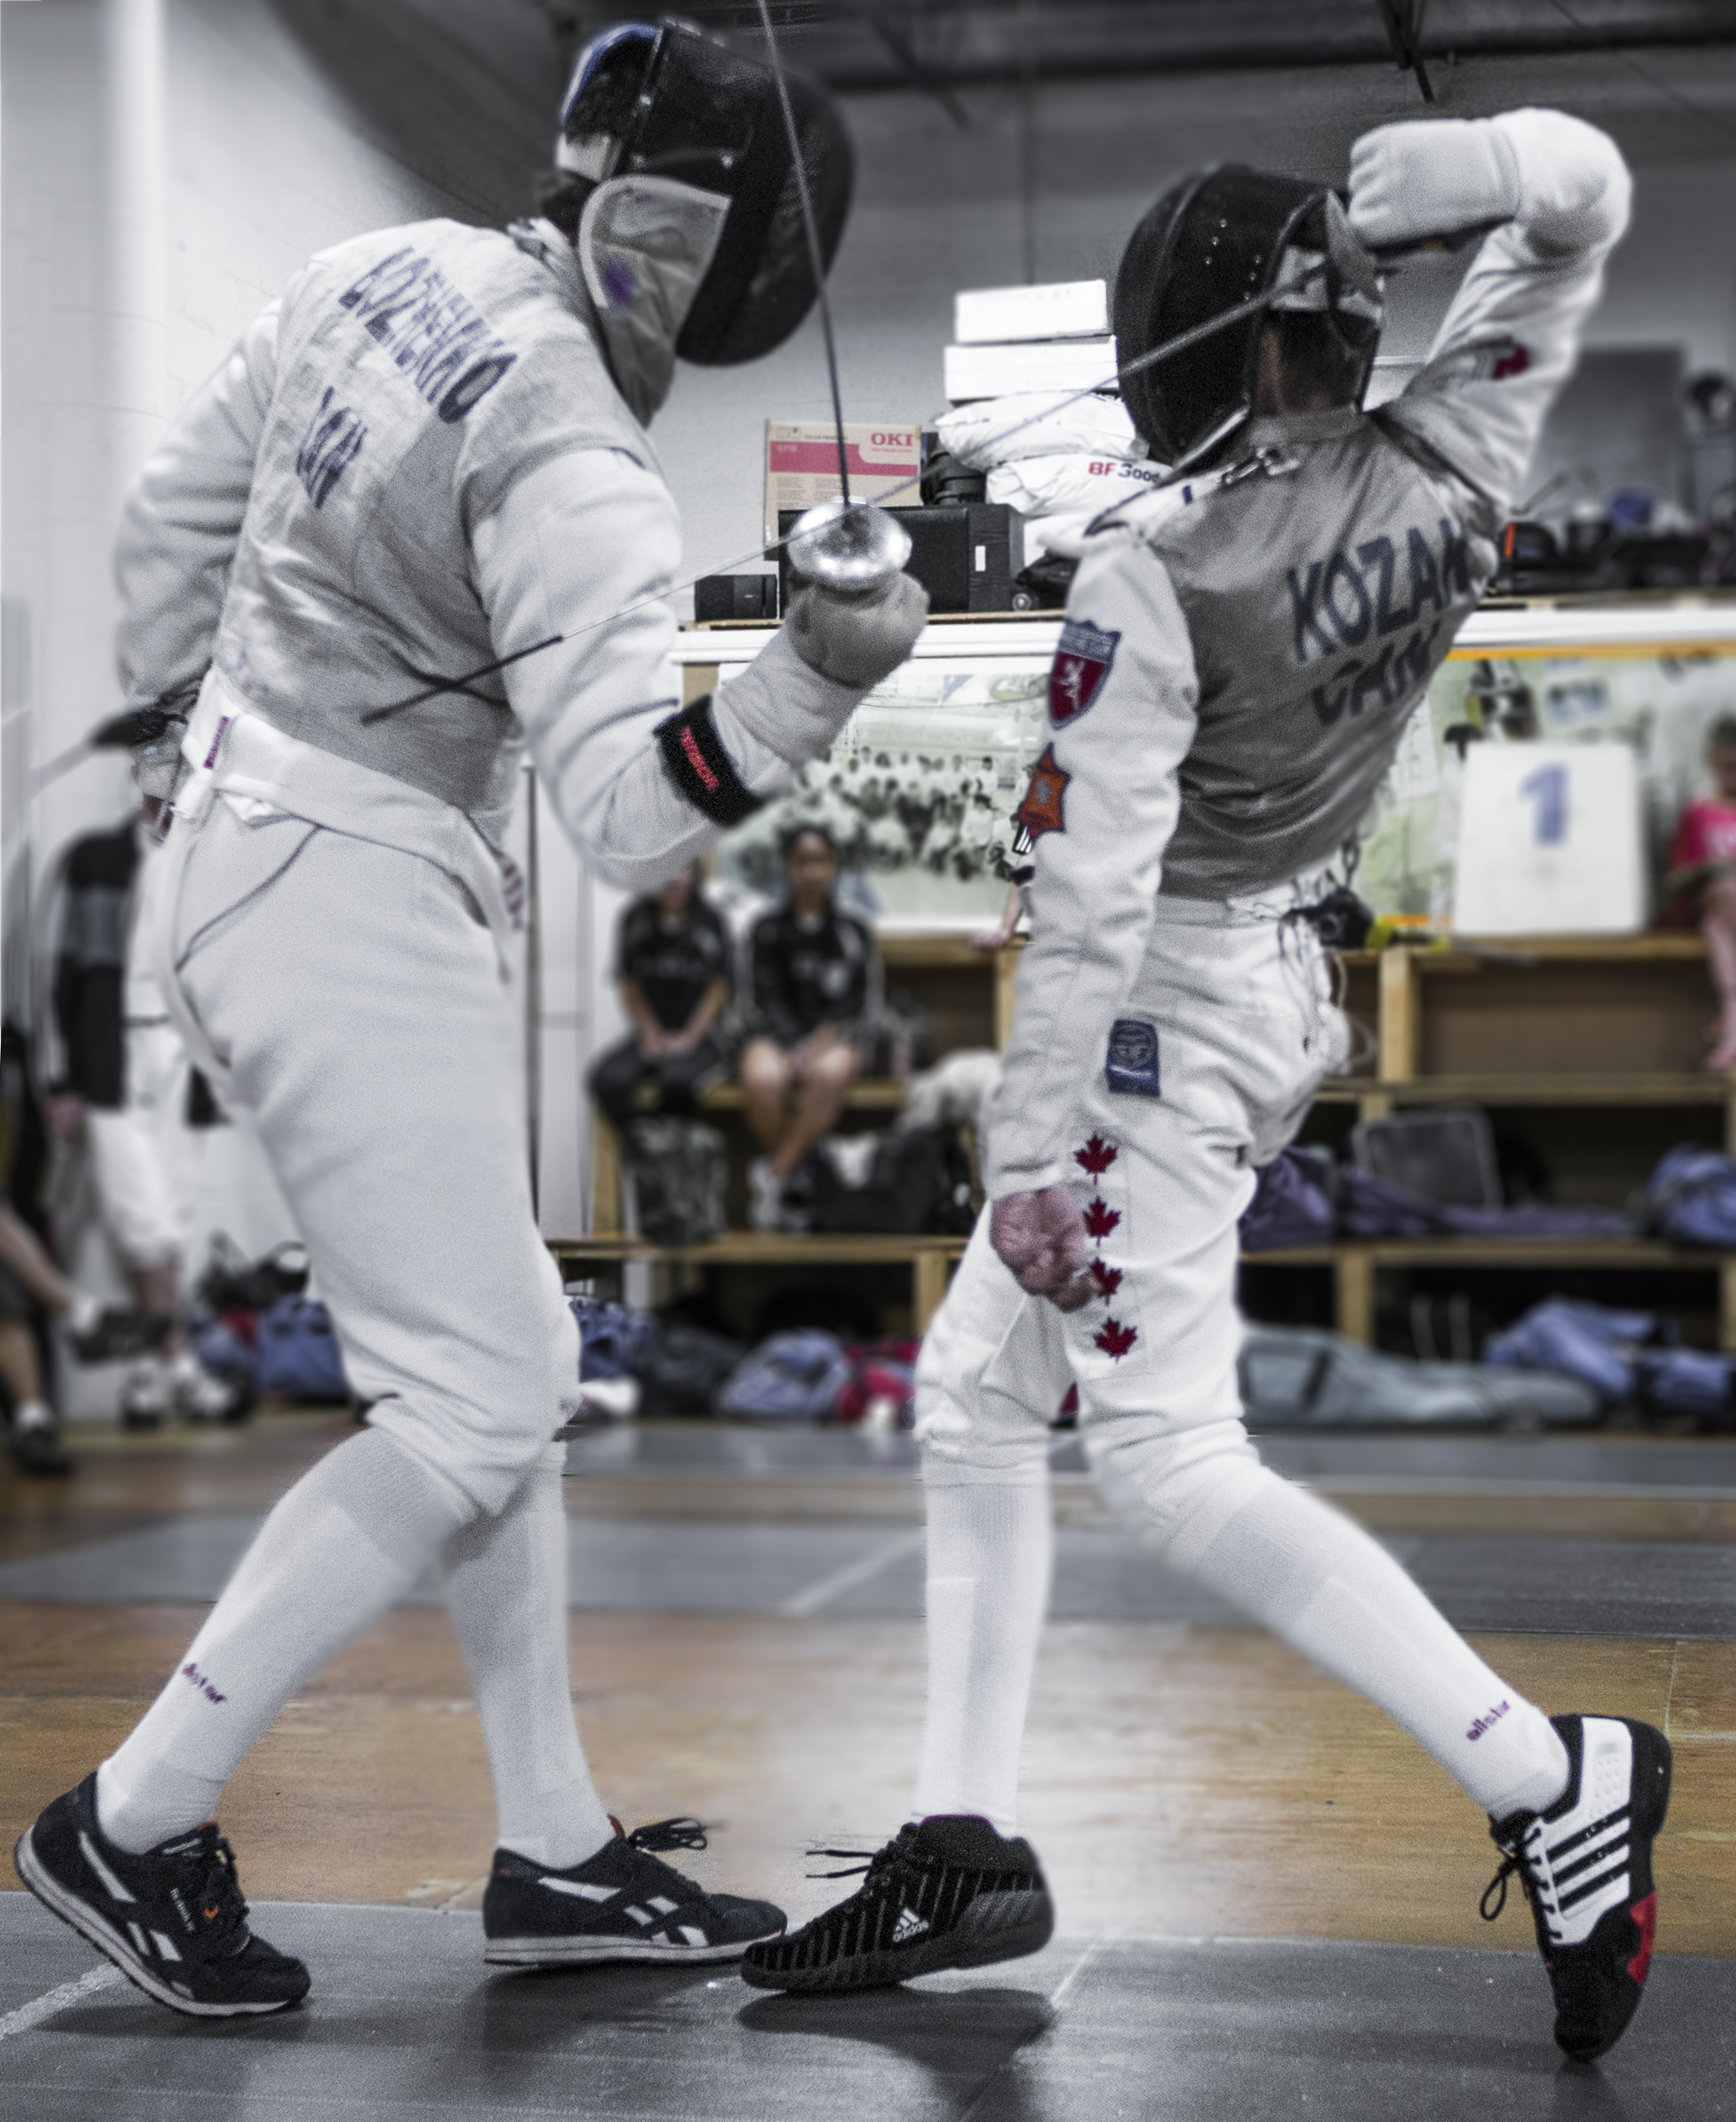Beginner Class  Vision  Toronto Fencing Club is dedicated to the development and refinement of all fencers from beginners and recreational fencers to high performance athletes, world champions, and Olympians.  Our vision is to promote the sport of fencing for athletes of all ages, from 6 to 60+.  50 Prince Andrew place, Toronto, M3C 2H4 |  | Toronto Fencing Club  Group  Training  Established 1998  
Monday  YOUTH FOIL: 6:40-7:40 PM  Steven Zhang  416-9022833/steven.sh.shang@hotmail.com  $20 member ($40 non-member)  FOIL 6:00-7:30 PM  MOHAMMAD MIRMOHAMMADI  647-46148177/ moesfencing@gmail.com  $40 member  Tuesday  Epee: 6:00 – 6:50 pm  Viktor Melnyk  437-3135155 /vitia20051112@gmail.com  $250/month ($25/class non-member)  Wednesday  Teen Epee: 6:00 – 6:50 pm  Viktor Melnyk  437-3135155 /vitia20051112@gmail.com  $250/month ($25/class non-member) | Wednesday  YOUTH FOIL 6:40-7:40 PM  Steven Zhang  416-9022833/steven.sh.shang@hotmail.com  $20 member ($40 non-member)  YOUTH ELITE EPEE 5:00–6:30 PM  andrew Hu  416-8879961 / andrewfencing@gmail.com  Age: 9 -12  $40 member ($60 non-member)  Thursday  Kid FOIL (6-9 YR): 5:00 – 6:00 pm  Viktor melnyk  604-8024637/ nastiyasadiy22@gmail.com  $250/month ($25/class non-member)  Teen EPEE: 6:00 – 7:00 pm  Viktor Melnyk  437-3135155 /vitia20051112@gmail.com  $250/month ($25/class non-member) |  |  |  | ADVANCE EPEE: 5:30–7 PM  andrew Hu  416-8879961 / andrewfencing@gmail.com  Age: 12 above  $40 member ($60 non-member)  Friday  Kid FOIL (5-7 YR): 6:00 – 7:00 pm  Stella Kim & Ysa Granert  647-8303913/ ysabel.granert@gmail.com  $20 member ($40 non-member)  ELITE FOIL 7:20-8:30 PM  Steven Zhang  416-9022833/steven.sh.shang@hotmail.com  $20 member ($40 non-member)  ADULT EPEE: 7:45-8:45  cATHY gRANERT  647-4493913/ acgranert@gmail.com  $20 member ($40 non-member)  FOIL 6:00-7:30 PM  MOHAMMAD MIRMOHAMMADI  647-46148177/ moesfencing@gmail.com  $40 member
647-2725438 | info@torontofencing.com |  |  |  | www.torontofencing.com

